**Challenge-2-Setting up Transit Gateway and VPC Endpoints for a Multi-VPC Architecture**

**Create 4 VPCs in Different AWS Regions**

* Navigate to **AWS Console > VPC**.
* Create **4 new VPCs** in different regions

Us-west-1 (N.California)

Ap-south-1 (Mumbai)

Eu-west-2 (London)

Ap-southeast-1 (Singapore)

* Assign **unique CIDR blocks** to avoid conflicts.
* Ensure **subnets** are properly configured for each VPC.

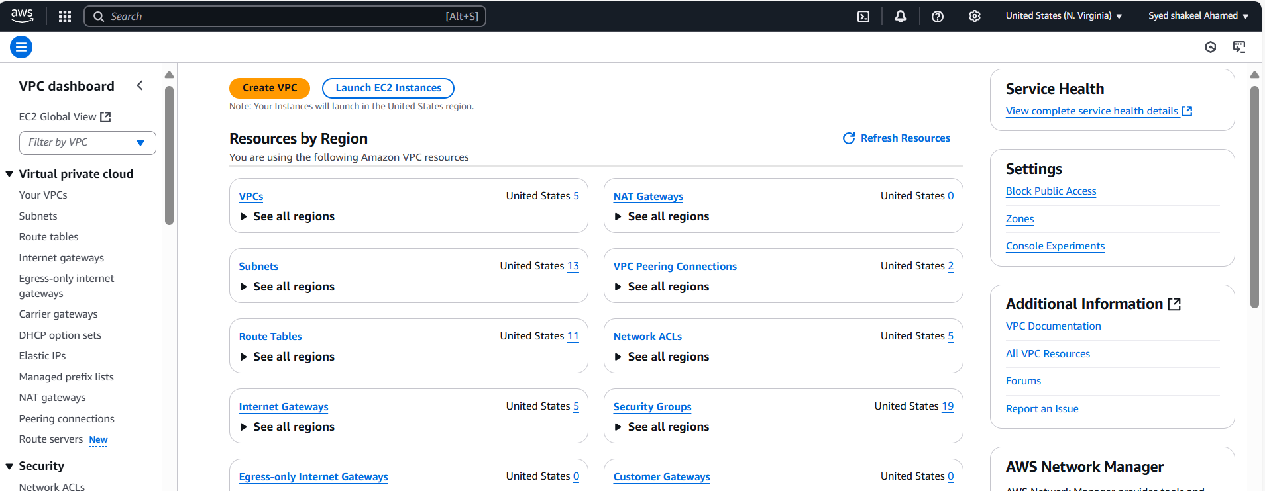

N.California

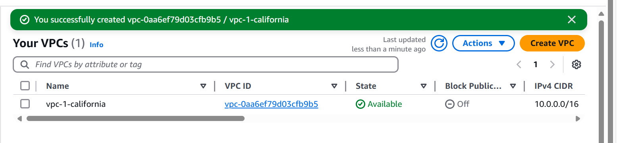

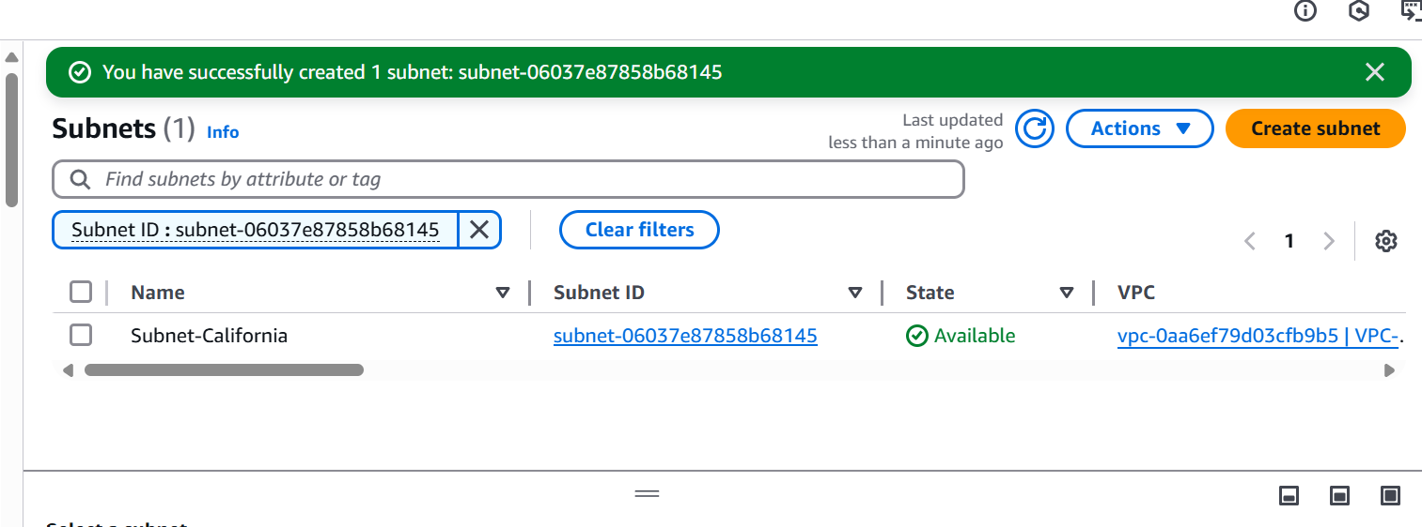

Mumbai

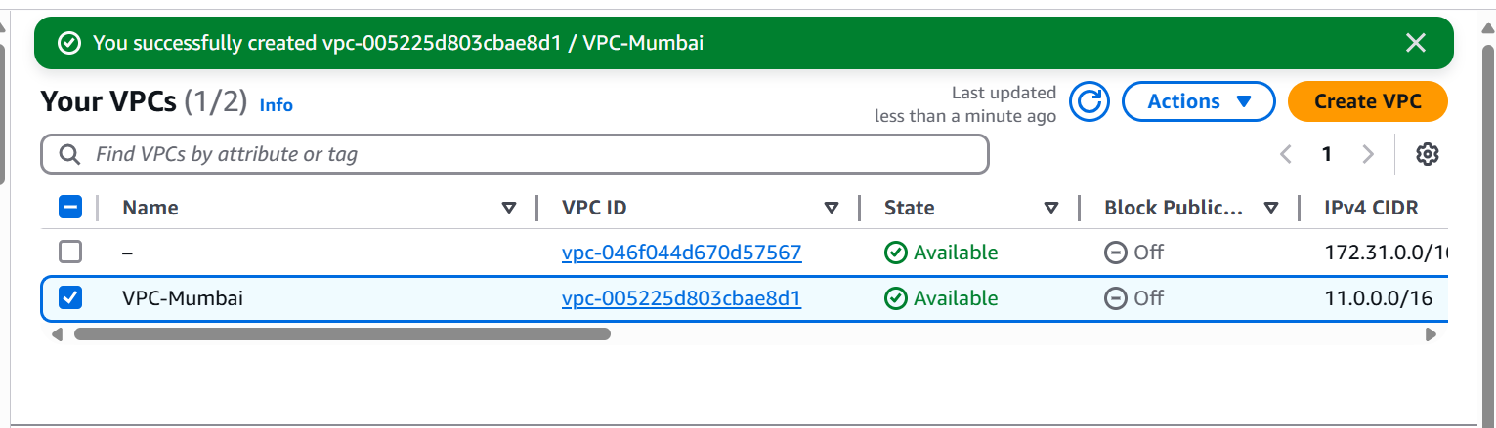

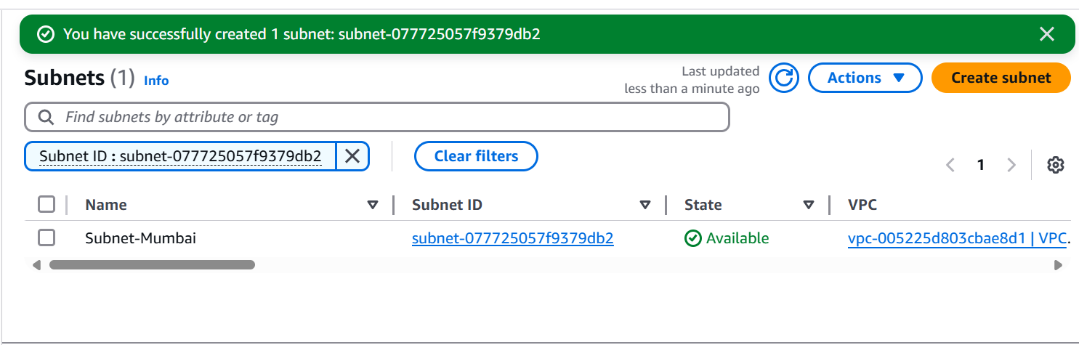

London

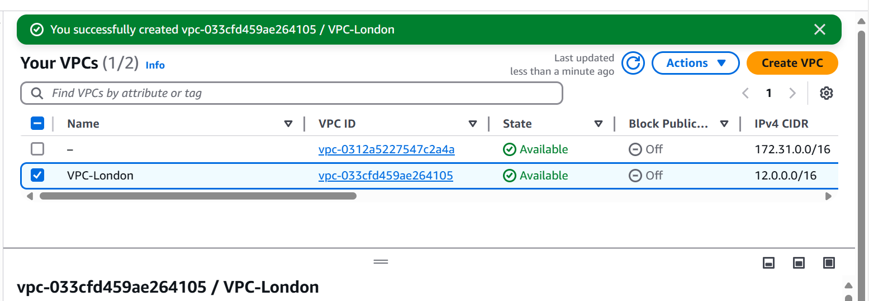

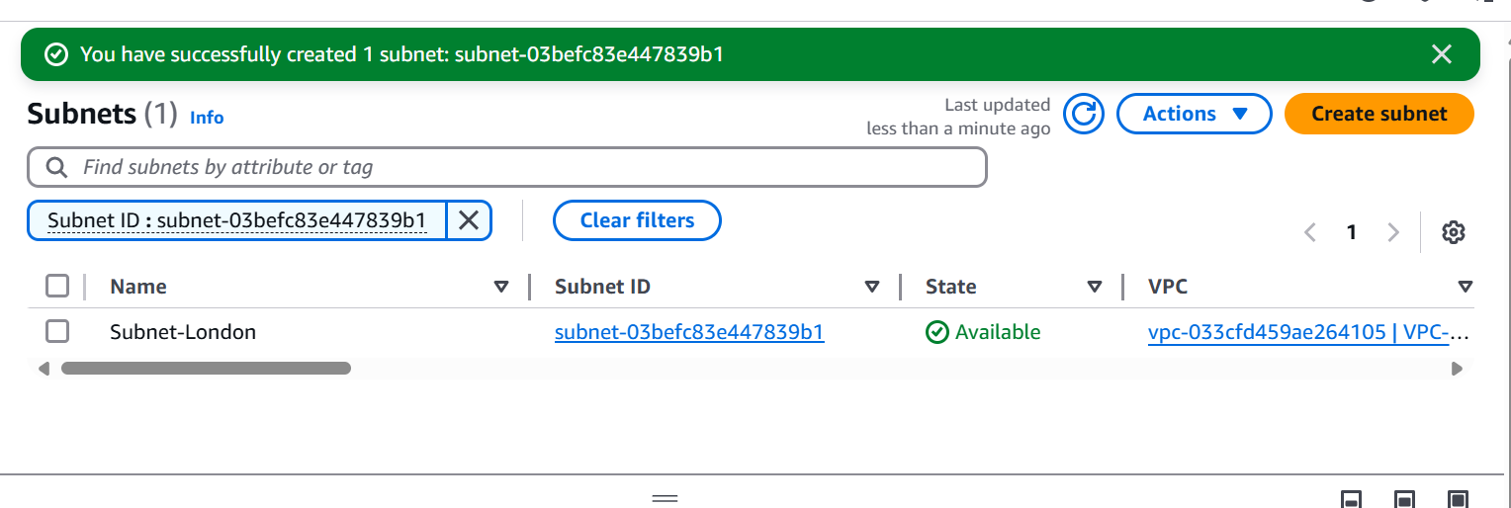

Singapore

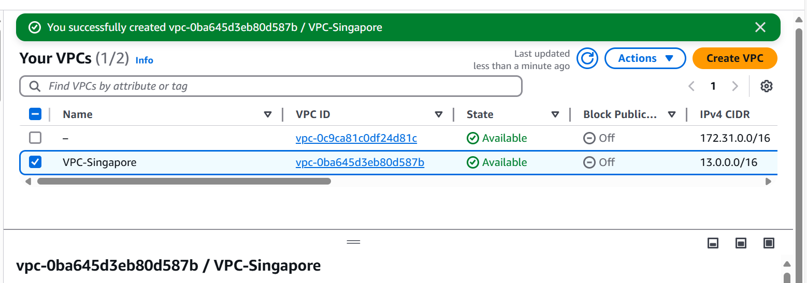

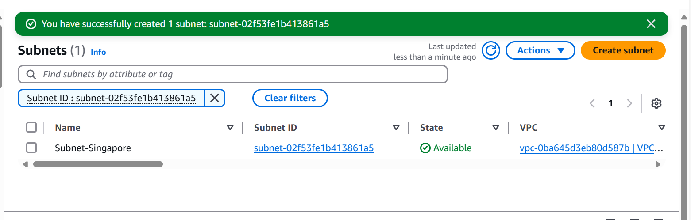

**2. Set Up AWS Transit Gateway**

* Create a **Transit Gateway** in one of the regions.
* Enable **multi-region peering** by creating **Transit Gateway Peering Attachments**.
* Accept the **peering requests** in each region.
* Configure **Transit Gateway Route Tables** to manage traffic flow.

Creating Transit Gateway in Mumbai region

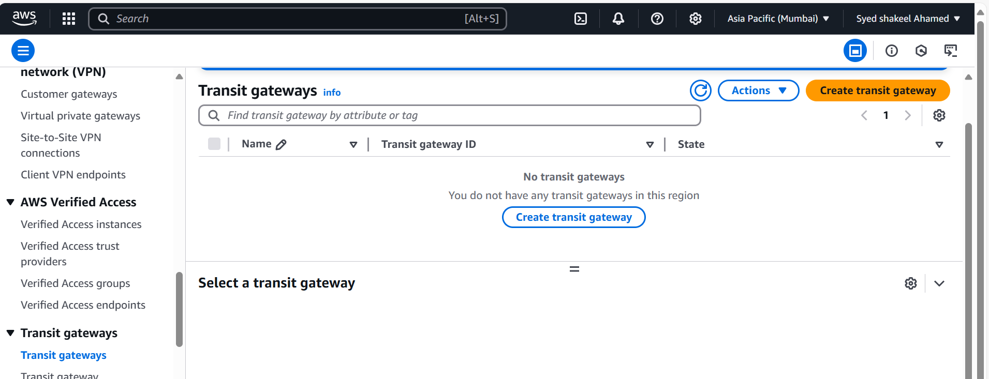

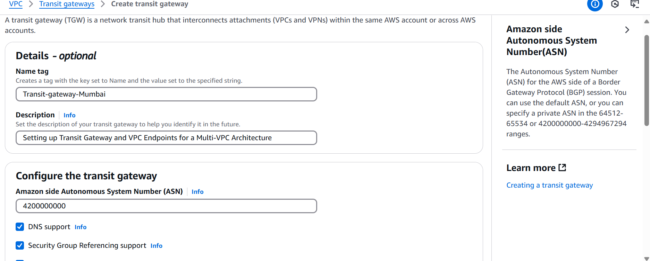

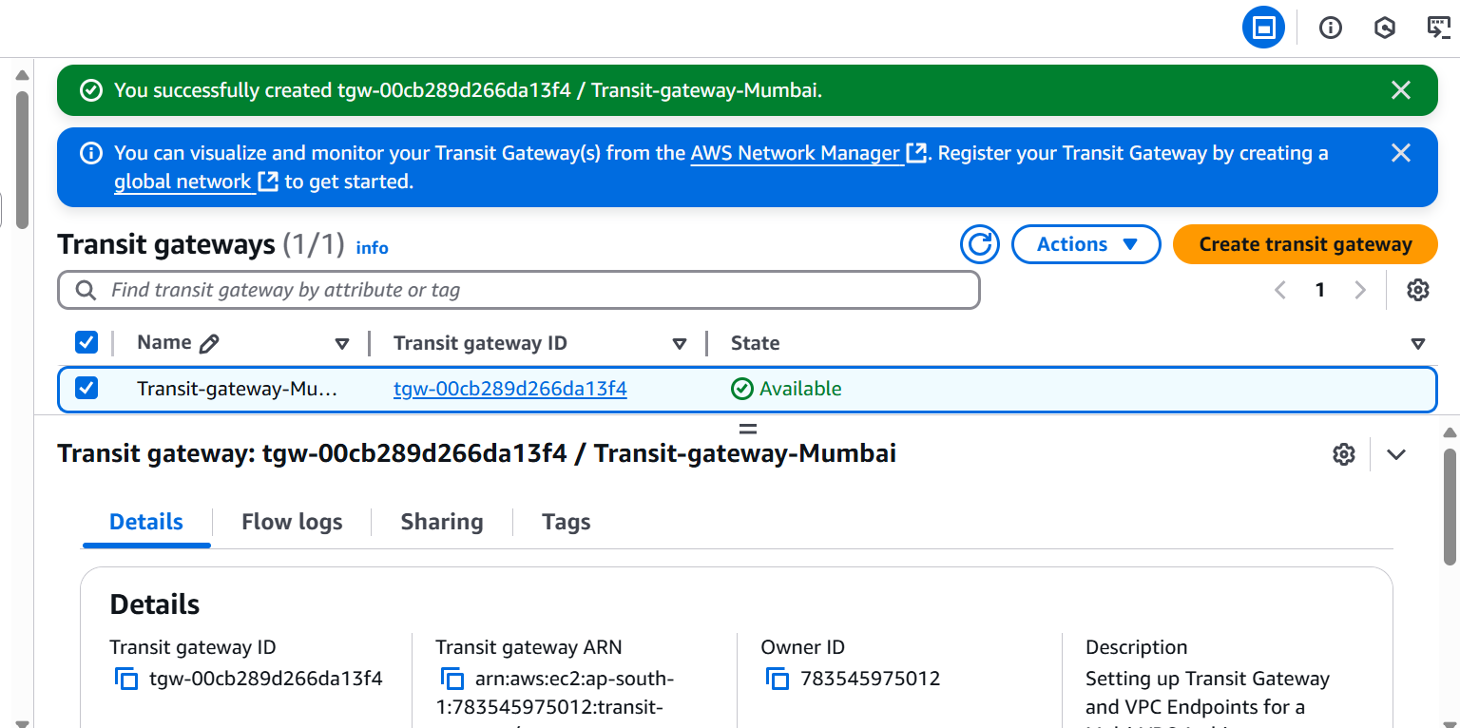

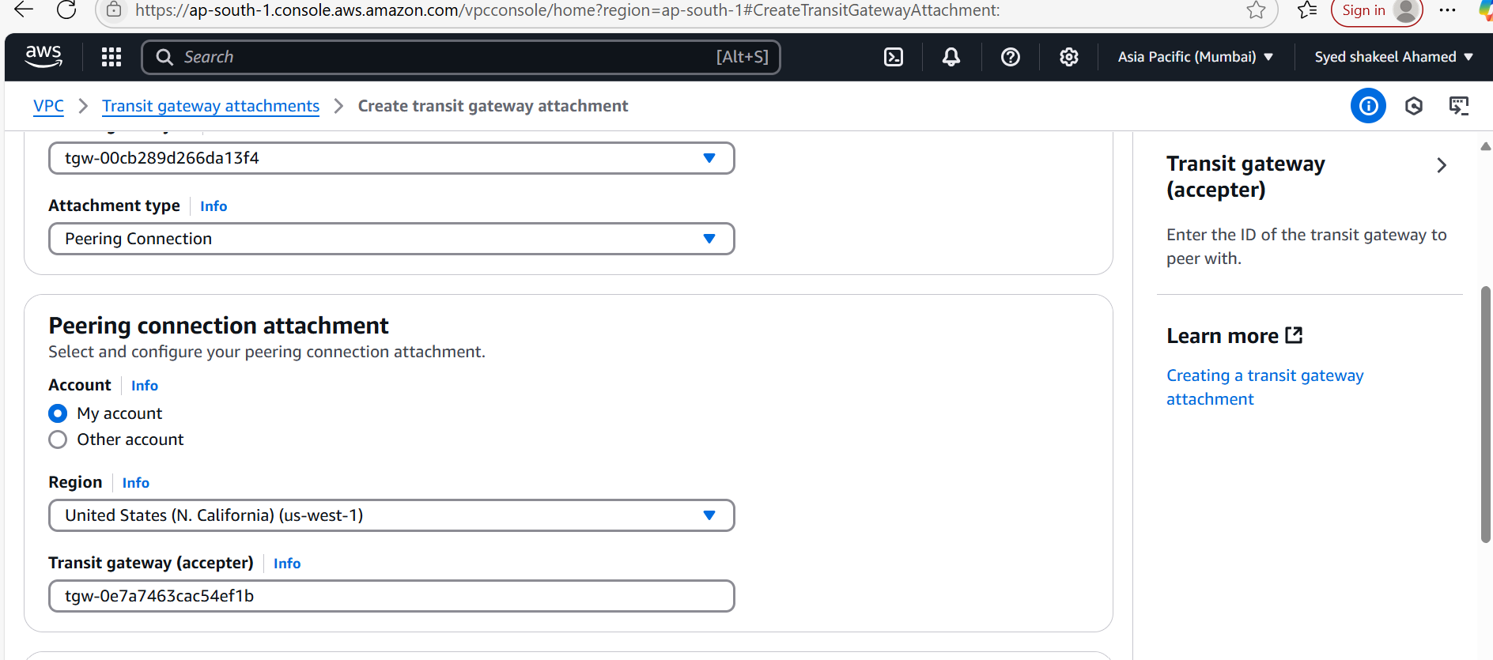

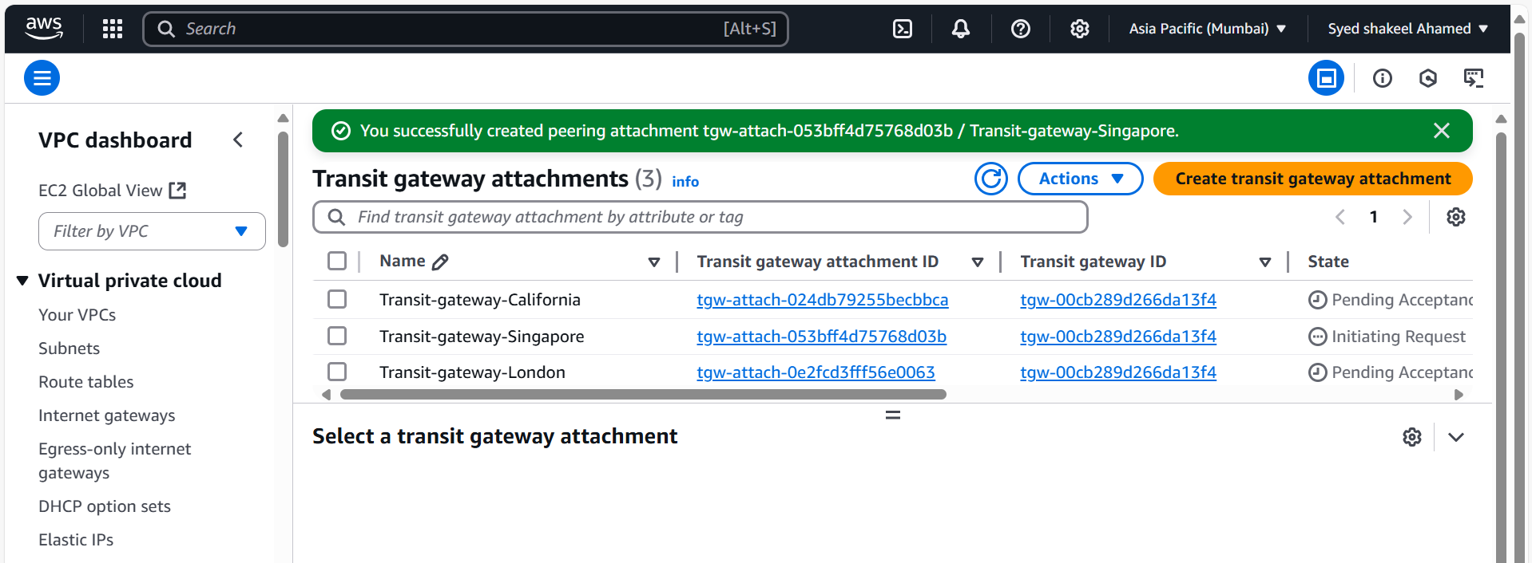

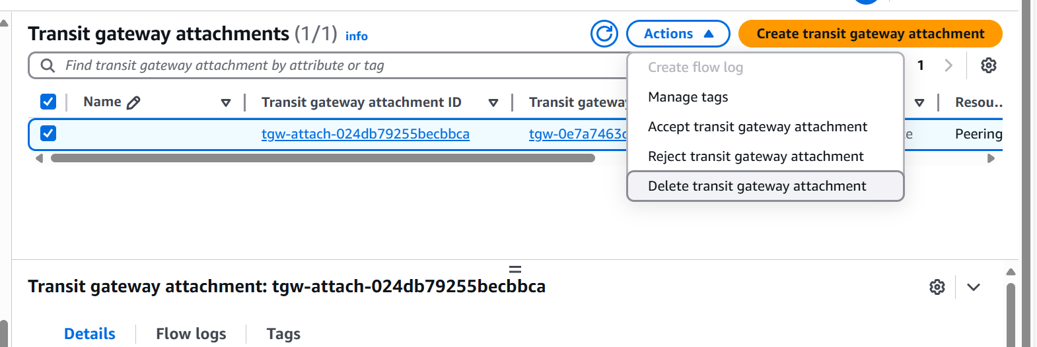

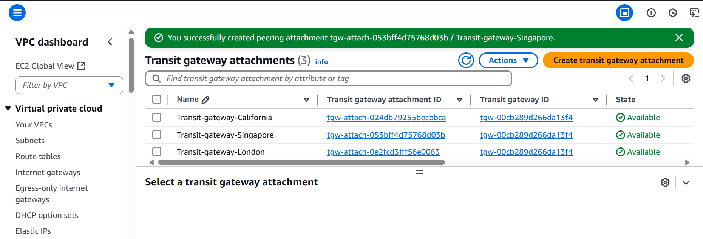

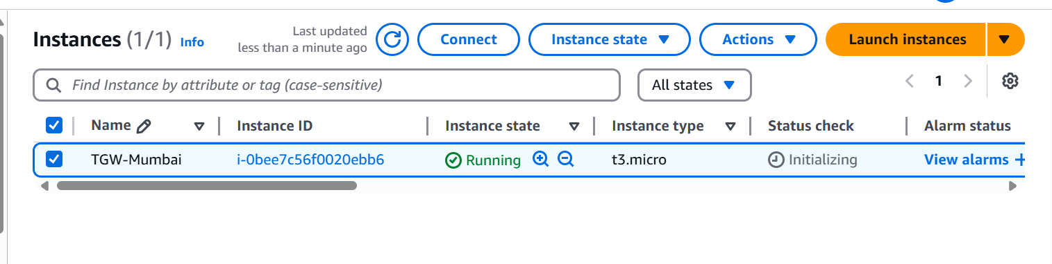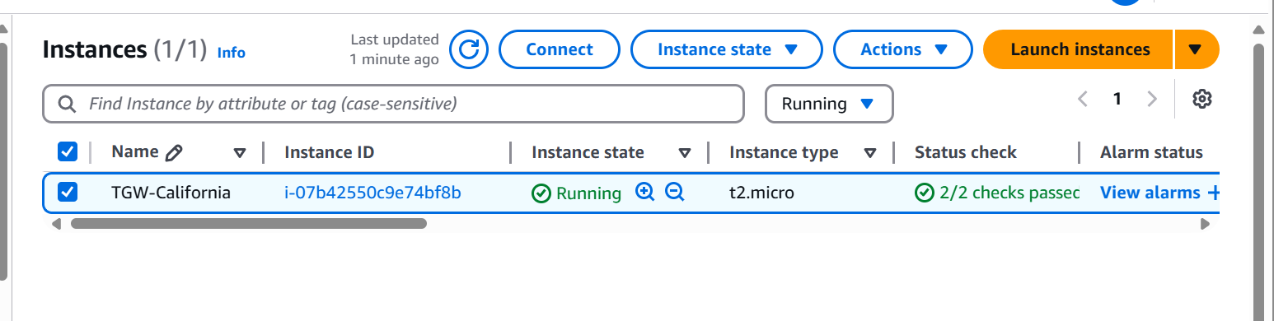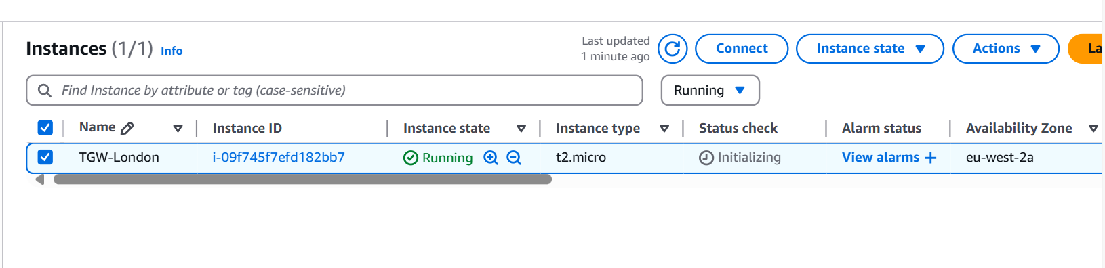

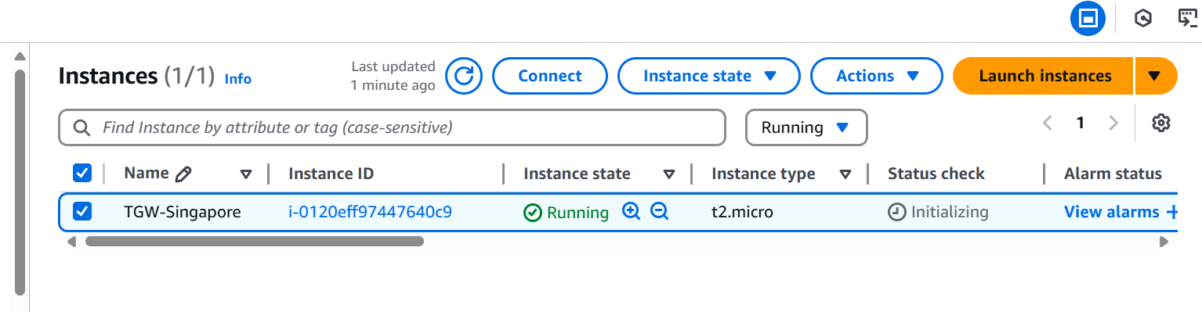

**3. Attach VPCs to Transit Gateway**

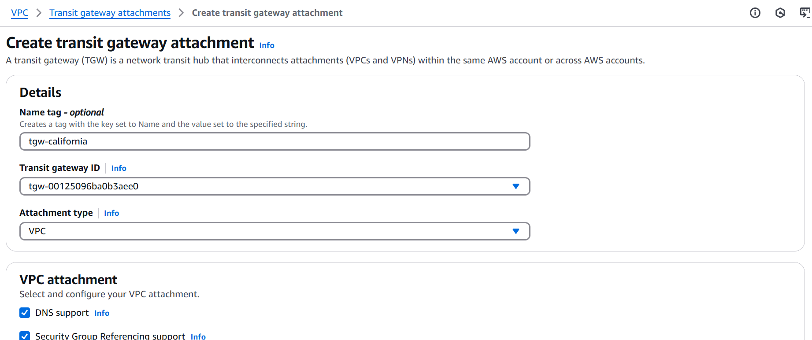

* In each region, **attach the VPCs** to the Transit Gateway.
* Define **routing rules** to allow communication between VPCs.
* Use **AWS Resource Access Manager (RAM)** to share Transit Gateway across accounts.

**4. Configure VPC Endpoints for Secure Access**

* Create **Interface VPC Endpoints** for services like **EC2, S3, DynamoDB**.
* Configure **Gateway Endpoints** for **Amazon S3 and DynamoDB**.
* Restrict access using **Security Groups and IAM policies**.

**5. Validate Connectivity & Security**

* Deploy **EC2 instances** in different VPCs.
* Test **cross-region communication** using **ping or traceroute**.
* Ensure services are **only accessible via VPC endpoints** (no public internet exposure).

For a detailed guide, check out [AWS Documentation](https://docs.aws.amazon.com/whitepapers/latest/building-scalable-secure-multi-vpc-network-infrastructure/transit-gateway.html) on **Transit Gateway and Multi-VPC Networking**. 🚀 Let me know if you need help with specific configurations!